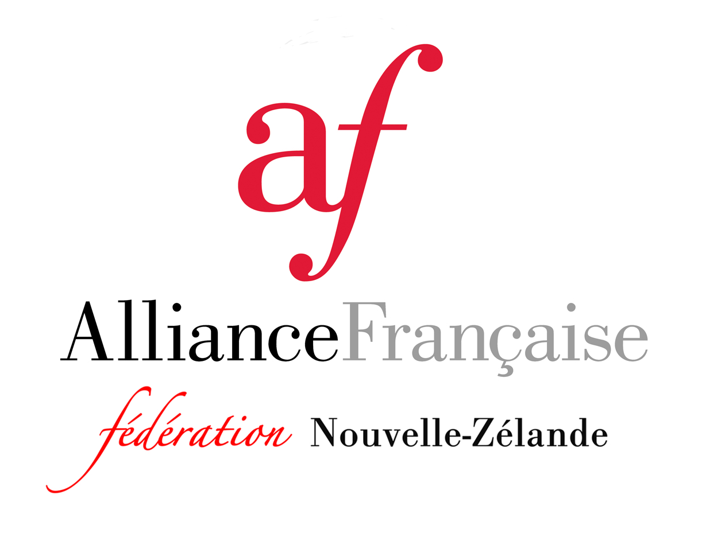

Fédération des Alliances Françaises de Nouvelle-Zélande Inc.

Year 12 Rules of the Alliance Française Concours Oral National 2021

1. The Year 12 Concours Oral National is open to secondary school students who are New Zealand citizens or who have a valid permanent resident visa in New Zealand, and who are enrolled in French at the Year 12 level in New Zealand.

2. Students are ineligible to enter if:
- They have a parent who is a native speaker of French, and with whom they live or speak to frequently in French.
- They have lived in a French-speaking country or province for more than six months in all (but excluding residence prior to their fifth birthday).
- They have spent more than six consecutive weeks in a French-speaking country and/or territory at any time in the previous five years.
- They have attended a school for more than six months where the language of instruction is French (even if French is not the official language of the country e.g. Lycée Français in London, Lycée Français in Vanuatu).
- They have previously won the Concours Oral National New Caledonia Trip Prize.

3. The Year 12 Concours Oral National will consist of a spoken French competition following the format (but not the content) of the DELF Junior/Scolaire Level B1 oral component (DELF Production Orale). This will be held on Saturday 25 September 2021. No advance preparation is required.

4. The one local candidate for the Year 12 Concours Oral National will be entered by the local Alliance Française, or its nominated representative, based on the local Year 12 Concours Oral or the local DELF Scolaire results.

5. PRIZES: The top candidate in the Year 12 Concours Oral National will win a selection of French books and DVDs (courtesy of the New Caledonian Government).

6. Beyond running the competition to select the winners and providing the prizes, neither the Alliances Françaises in New Zealand nor the Fédération des Alliances Françaises de Nouvelle-Zélande Inc. undertake any further responsibility.

