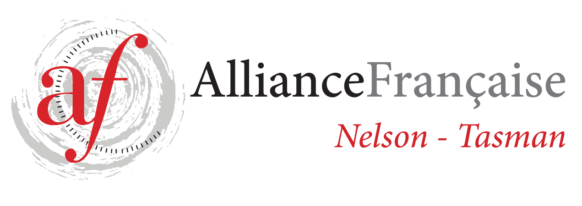
Alliance Française de Nelson Enrolment Form
French Classes for Adults - Term 4 2021
Intermediate DELF B 1.4 - Tutor: Anne Wheeler

STARTING WEDNESDAY 20/10 - last class on 15/12 (9 weeks)
1h30 class: 5.30 - 7.00 pm
Fees: $121.50 for 9 weeks (7 students minimum)
Please note that the fees are due at the beginning of the term.
You need to be an Alliance Française Nelson Tasman member to benefit from French lessons.
If you are a new student, please do so on https://www.afnelsontasman.org/join-us.html
Membership = ​$40 individual / Couple membership = $60
20/10 27/10 3/11 10/11 17/11 24/11
1/12 8/12 15/12

Name:
Phone:
Email:
Enrolment form to be forwarded to tutor annewheelerfrench@gmail.com
and full amount for the term’s lessons to be paid 1 week prior to each term.
Payment will be strictly on a term-by-term basis and refunds would only be made in the circumstances whereby Alliance Française de Nelson had to cancel classes.
All the handouts provided to the students are the property of Alliance Française Nelson.
In case of no show to the classes, handouts will be provided at the discretion of the teacher.
Regular attendance is necessary to make progress – Please contact the tutor if you can’t attend a class – Anne Wheeler 0273819791
Fees to be paid before the beginning of the term

Treasurer contact: Toni Chittenden toni.chittenden@outlook.co.nz

For further information, contact tutor: annewheelerfrench@gmail.com

Signed:

