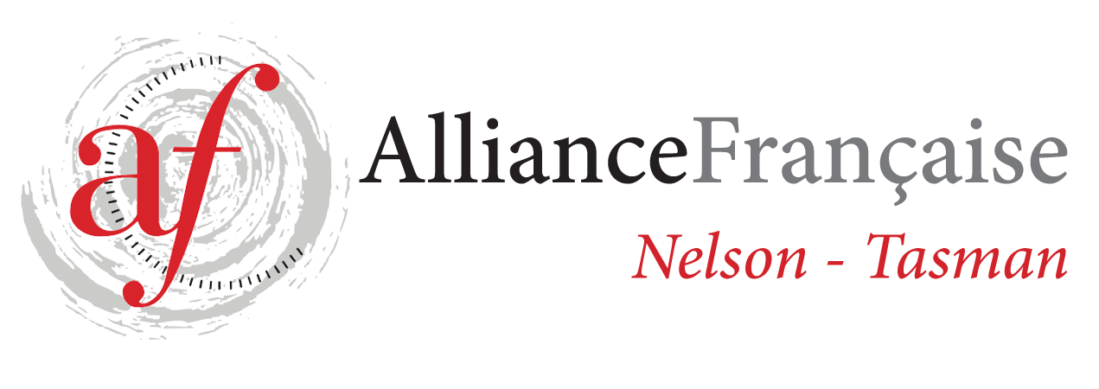
Alliance Française de Nelson Enrolment Form
French Classes for Adults - Term 4 2021
Beginners Level 3 - DELF A1.3 - Tutor: Liz Masson

STARTING THURSDAY 21/10- last class on 16/12 (9 weeks)
Fees: $81.00 for 9 weeks - (1h classes) - 7 students minimum
Please note that the fees are due at the beginning of the term.
You need to be an Alliance Française Nelson Tasman member to benefit from French lessons.
If you are a new student or haven’t renewed you French Alliance fees 2020, please do so on
https://www.afnelsontasman.org/join-us.html
Membership = ​$40 individual / Couple membership = $60
21/10 28/10 4/11 11/11 18/11 25/11
2/12 9/12 16/12

Name:
Phone:
Email:
Enrolment form to be forwarded to tutor lizmasson13@gmail.com
and full amount for the term’s lessons to be paid 1 week prior to each term.
Payment will be strictly on a term by term basis and refunds would only be made in the circumstances whereby Alliance Française de Nelson had to cancel classes.
All the handouts provided to the students are the property of Alliance Française Nelson.
In case of no show to the classes, handouts will be provided at the discretion of the teacher.
Regular attendance is necessary to make progress – Please contact the tutor if you can’t attend a class - Liz Masson 021 256 71 96

Fees to be paid before the start of the Term.
For further information, contact tutor: lizmasson13@gmail.com

Signed:

