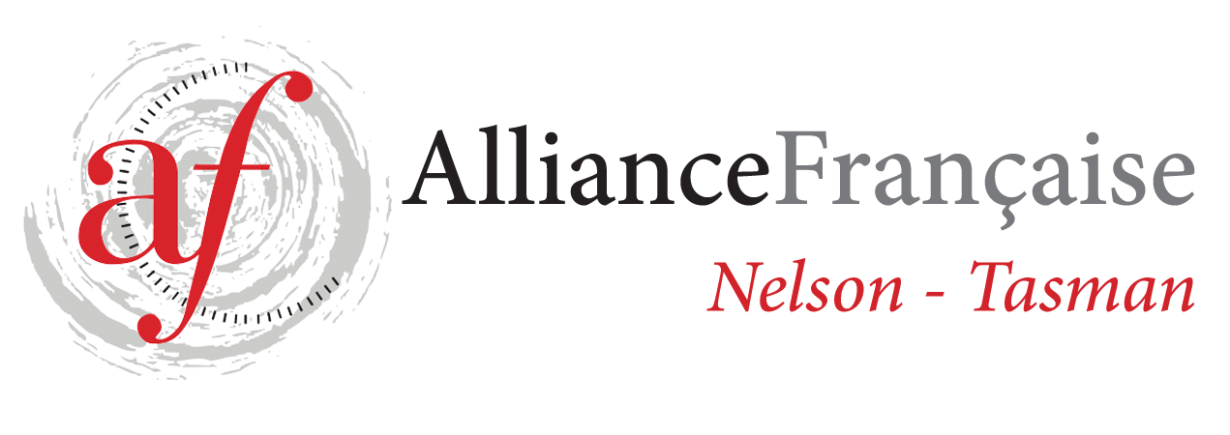
Alliance Française de Nelson Enrolment Form
French Classes for Adults – Term 3 2020
Beginners Level 1 - DELF A1.1 level – Tutor: Liz Masson

Fees: $90.00 for 10 weeks – class of 7 students minimum

You need to be an Alliance Française Nelson Tasman member to benefit from French lessons.
If you are a new student or haven’t renewed you French Alliance fees 2020, please do so on
https://www.afnelsontasman.org/join-us.html
Membership = ​$40 individual / Couple membership = $60
23/7 30/7 6/8 13/8 20/8 27/8
3/9 10/9 17/9 24/9

Name:
Phone:
Email:
Enrolment form to be forwarded to tutor annewheelerfrench@gmail.com
and full amount for the term’s lessons to be paid 1 week prior to each term.
Payment will be strictly on a term by term basis and refunds would only be made in the circumstances whereby Alliance Française de Nelson had to cancel classes.
All the handouts provided to the students are the property of Alliance Française Nelson.
In case of no show to the classes, handouts will be provided at the discretion of the teacher.
Treasurer contact: Toni Chittenden rock.security@xtra.co.nz
Regular attendance is necessary to make progress – Please contact the tutor if you can’t attend a class - Liz Masson 021 256 71 96
Payments can be made by online banking or by bank transfer: 02-0704-0380910-000 BNZ Alliance Française de Nelson or by cheque addressed to Alliance Française de Nelson-Tasman and given to the teacher at the beginning of the term. Reference: Night Classes T 3 2020
For further information, contact tutor: annewheelerfrench@gmail.com

Signed:

