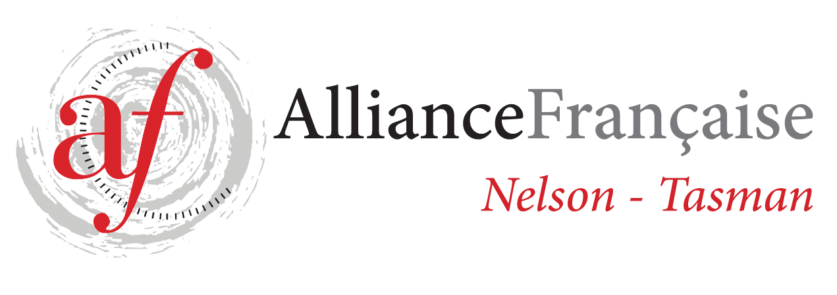
http://www.afnelsontasman.org
Alliance Française de Nelson Enrolment Form
French Classes for Adults – Term 3 2018
Advanced - DELF B1 ongoing

Fees: $135.00 for 1.30 classes – 10 weeks (minimum 6 students)
NMIT Room S106 (entry Nile Street)

Wednesday 7.10 to 8.40 pm
25/7 1/8 8/8 15/8 22/8 29/8
5/9 12/9 19/9 26/9

Name:
Phone:
Email:
Enrolment form to be forwarded to tutor annewheelerfrench@gmail.com and full amount for the term’s lessons to be paid 1 week prior to each term.
Payment will be strictly on a term by term basis and refunds would only be made in the circumstances whereby Alliance Française de Nelson had to cancel classes.
All the handouts provided to the students are the property of Alliance Française Nelson.
In case of no show to the classes, handouts will be provided at the discretion of the teacher.
Treasurer contact: Toni Chittenden rock.security@xtra.co.nz
Regular attendance is necessary to make progress – Please contact the tutor if you can’t attend a class on 027 38 19 791.
Payments can be made by online banking or by bank transfer: 02-0704-0380910-000 BNZ Alliance Française de Nelson or by cheque addressed to Alliance Française de Nelson-Tasman and given to the teacher at the beginning of the term. Reference: Night Classes T 3 2018
For further information, contact tutor: annewheelerfrench@gmail.com
027 38 19 791

Signed:

