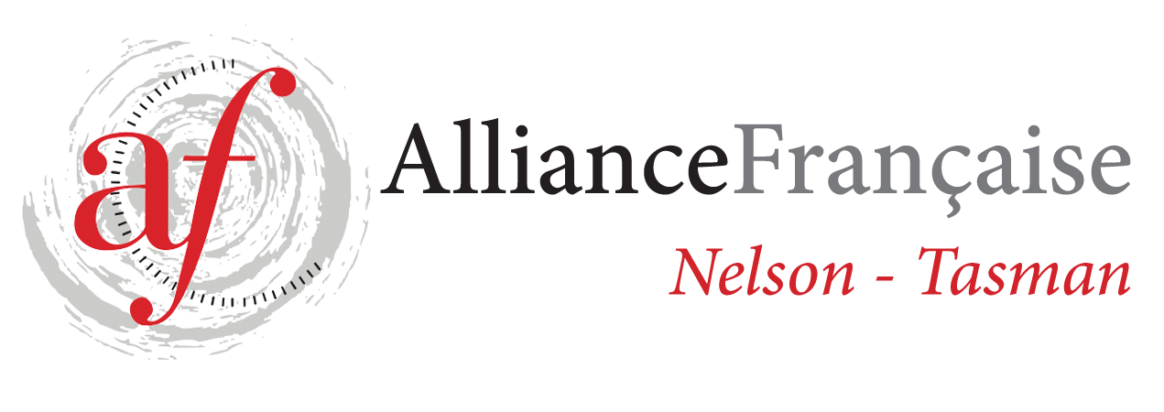
Alliance Française de Nelson Enrolment Form
French Classes for Adults - Term 2 2021
Beginners Level 4 – DELF A 1.4 - Tutor: Anne Wheeler

STARTING TUESDAY 4/5 - last class on 6/7 (10 weeks)
1h30 class: 5.30 - 7.00 pm
Fees: $135.00 for 10 weeks (7 students minimum)
Please note that the fees are due at the beginning of the term.
You need to be an Alliance Française Nelson Tasman member to benefit from French lessons.
If you are a new student, please do so on https://www.afnelsontasman.org/join-us.html
Membership = ​$40 individual / Couple membership = $60
4/5 11/5 18/5 25/5
1/6 8/6 15/6 22/6 29/6
6/7

Name:
Phone:
Email:
Enrolment form to be forwarded to tutor annewheelerfrench@gmail.com
and full amount for the term’s lessons to be paid 1 week prior to each term.
Payment will be strictly on a term-by-term basis and refunds would only be made in the circumstances whereby Alliance Française de Nelson had to cancel classes.
All the handouts provided to the students are the property of Alliance Française Nelson.
In case of no show to the classes, handouts will be provided at the discretion of the teacher.
Regular attendance is necessary to make progress – Please contact the tutor if you can’t attend a class – Anne Wheeler 0273819791
Payments can be made by online banking or by bank transfer: 02-0704-0380910-000 BNZ Alliance Française de Nelson or by cheque addressed to Alliance Française de Nelson-Tasman and given to the teacher at the beginning of the term. Reference: Night Classes T 2 2021
Treasurer contact: Toni Chittenden toni.chittenden@outlook.co.nz
For further information, contact tutor: annewheelerfrench@gmail.com

Signed:

